**MySQL project**

-- Analysation begins of The Lifestyle Data--

use lifestyle;

SELECT

*

FROM

health_data;

-- changing column name--

alter table health_data rename column `Person ID` to Personid;

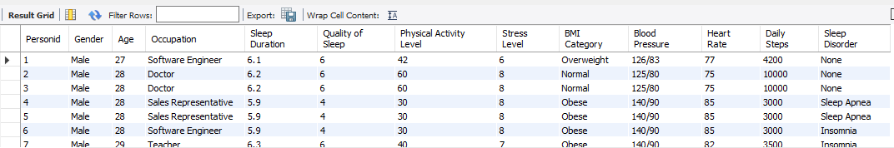

-- showing female and male data--

SELECT

*

FROM

health_data

WHERE

Gender = 'Female';

SELECT

*

FROM

health_data

WHERE

Gender = 'Male';

SELECT

COUNT(Gender)

FROM

health_data

WHERE

Gender = 'Female';

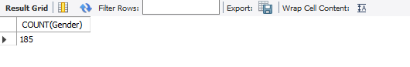

SELECT

COUNT(Gender)

FROM

health_data

WHERE

Gender = 'Male';

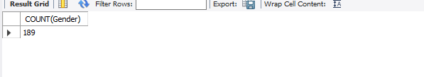

-- avg age--

SELECT

AVG(Age)

FROM

health_data;

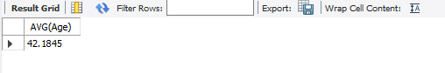

-- Common Occupation--

SELECT

MAX(Occupation)

FROM

health_data;



-- average quality of sleep--

SELECT

AVG(`Quality of Sleep`)

FROM

health_data;

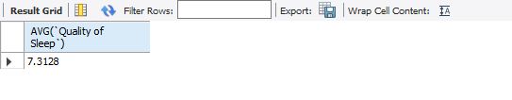

-- Are there any individuals with extremely low physical activity--

SELECT

Personid, Age, Gender, `Daily Steps`

FROM

health_data

WHERE

`Daily Steps` < 4000;

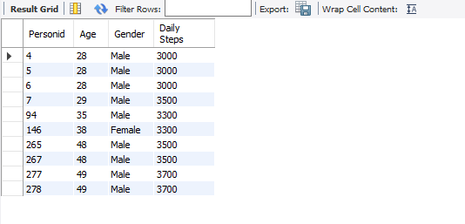

-- Relation between Physical Activity, Stress lever--

SELECT

`Physical Activity Level`, `Stress Level`

FROM

health_data;

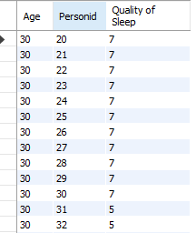

-- ..... Occupation-specific Analysis ..... --

-- What is the average stress level for individuals in each occupation?

select avg(`Stress Level`) as 'Overall stress', Occupation from health_data

group by Occupation;

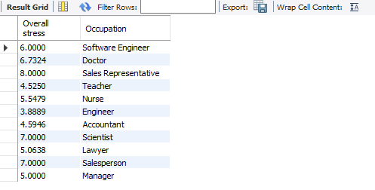

-- Which occupation has the highest percentage of individuals with a sleep disorder?--

select count(Personid) from health_data;

select distinct(Occupation) from health_data;

select count(Personid) as 'Overall count', Occupation from health_data where `Sleep Disorder` != 'None'

group by Occupation;

